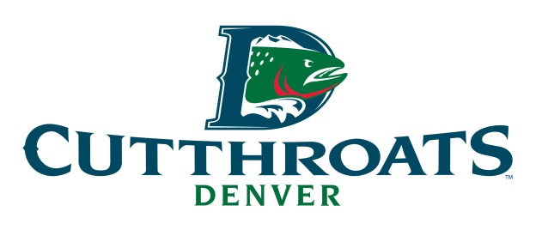
LEARN THE BASICS OF ICE HOCKEY WITH YOUR

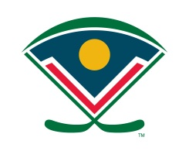
DENVER CUTTHROATS
AT SOUTHWEST RINK/SKYLINE PARK!
February 4th 4:00pm-6:00pm
February 7th 5:00pm-7:00pm

THIS IS A CHANCE FOR CHILDREN AGES 11 AND UNDER TO LEARN THE BASICS OF SKATING/ICE HOCKEY

Learn basic hockey skating and stick handling skills FOR FREE with the Denver Cutthroats professional hockey team! Sign your child up for a skating session NOW!

Location: Southwest Rink at Skyline Park
Corner of 16th and Arapahoe (Downtown Denver)

Rental skates are available at the Southwest Rink for participating children free of charge! All other equipment will be available at the rink as well.

Please contact Alexandra Hefter (Director of Community Relations) if you have any questions and/or would like to sign up:
Alexandra Hefter
ahefter@denvercutthroats.com
303-295-3474
SPOTS ARE LIMITED - SIGN UP NOW!
This is a unique experience the Cutthroats are offering young children free of charge. The first hour will be on the ice learning to skate and stick handling skills. The Cutthroats will spend the second hour mingling with the general public and signing autographs.

Anyone and everyone is welcome to come, watch the skate, and meet the Cutthroats!
